An Undivided Heart

FOR KIDS

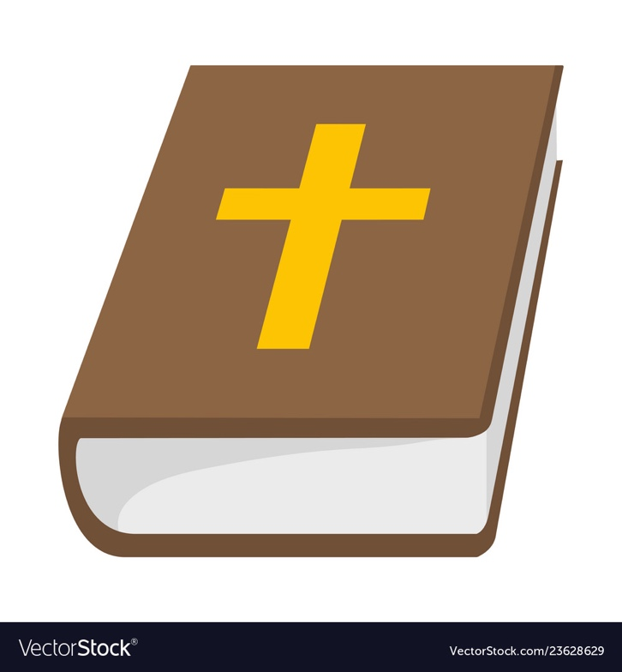

Lesson 1

Goal
- Understand a Biblical definition of worship

What is Worship?
Worship is something Christians talk about all the time. But what is it? Is it something that happens through music? Is it something that only occurs in church? As we begin our lesson, write down what you think
worship is. Draw a picture or write examples of what you believe it means to
worship.
Worship is…

According to the Bible, worship means to ascribe worth to something. Christians pursue God by putting their relationship with God above everything else. Followers of Jesus ascribe worth to God in their thoughts and actions every day. These things are proper worship.
The Bible has many examples of men and women worshipping God. Look up the following verses and record God’s different instructions about worship for His followers.
Exodus 34:14
_____________________________________________________________________________________
_____________________________________________________________________________________
2 Kings 17:36
_____________________________________________________________________________________
_____________________________________________________________________________________
2 Kings 17:39
_____________________________________________________________________________________
_____________________________________________________________________________________
Psalm 29:2
_____________________________________________________________________________________
_____________________________________________________________________________________
Psalm 95:6
_____________________________________________________________________________________
_____________________________________________________________________________________
Psalm 99:5
_____________________________________________________________________________________
_____________________________________________________________________________________
God clearly commands his followers in the Old Testament to worship Him and Him alone. But how are we to worship God? The New Testament unpacks this more for those of us who live after Jesus’ life, death, and resurrection. Read these verses and write down how we are to worship.
John 4:24
_____________________________________________________________________________________
_____________________________________________________________________________________
Romans 12:1
_____________________________________________________________________________________
_____________________________________________________________________________________
Colossians 3:16-17
_____________________________________________________________________________________
_____________________________________________________________________________________
_____________________________________________________________________________________
_____________________________________________________________________________________
Philippians 4:4
_____________________________________________________________________________________
_____________________________________________________________________________________
Hebrews 12:28
_____________________________________________________________________________________
_____________________________________________________________________________________

As we have read all these passages about worship, it becomes clear that worship is not just an event, it’s a lifestyle. True worship is living your life for God no matter what happens. It recognizes that God is in control. Therefore, even when times are tough we can worship Him, knowing He is sovereign.
Since worship is a lifestyle, reflect on this question: do you live a lifestyle of worship? Below write down the different “buckets” (areas) of your life, such as school, music, church, sports, family, and other activities. Write down how you can live a lifestyle of worship in each of these areas.
Bucket #1:

Bucket #4:
Bucket #3:
Bucket #2:
Review
Use this review to test the things you’ve learned from this first lesson! If you can’t remember, look back at the last couple of pages!

What does worship mean?
_____________________________________________________________________________________
_____________________________________________________________________________________
_____________________________________________________________________________________

What is one example of a command to worship God from the Old Testament?
_____________________________________________________________________________________
_____________________________________________________________________________________

How are we to worship according to John 4:24?
_____________________________________________________________________________________
_____________________________________________________________________________________

Fill in the blank: worship is not just an event, it’s a _________________

Spend some time praying, asking God to help you live a life worship. Give God praise for who He is and ask the Holy Spirit to show you how you can respond in your daily life.

Lesson 2

Goal
- Understand the attitude that comes with our service to God

A Worshipful Attitude
Living a lifestyle of worship means that we are called to serve God in all we do. While people mostly measure others by their accomplishments, that is not how God views us. God is in fact extremely concerned with the attitude with which we serve. In the attitude is wrong, the service is pointless!

Read 1 Corinthians 13:1-3. What point is the apostle Paul trying to make that concerns with having the right attitude to your service?
_____________________________________________________________________________________
_____________________________________________________________________________________
_____________________________________________________________________________________
_____________________________________________________________________________________

Living a lifestyle of worship requires an attitude of love. Paul goes on to describe this type of attitude in the following verses. Read 1 Corinthians 13:4-7. On the next page, write down all the descriptions of what he says love is!
Love is…

It’s hard to have a worshipful attitude that loves others. Of all the things Paul says, which is hardest for you? Why?
_____________________________________________________________________________________
_____________________________________________________________________________________
_____________________________________________________________________________________

Read Matthew 23:27-28. The teachers of the law and the Pharisees were the religious leaders of the day. What does Jesus call them? According to Jesus, what was their problem?
_____________________________________________________________________________________
_____________________________________________________________________________________
_____________________________________________________________________________________
_____________________________________________________________________________________
_____________________________________________________________________________________
_____________________________________________________________________________________
_____________________________________________________________________________________
_____________________________________________________________________________________

One of the purposes of our service to God is to bear fruit. We want to faithfully work at the things God has in store for us so that the kingdom of God continues to grow. But how do we do so? In John 15, Jesus tells us how. Read John 15:1-8.

According to this passage, who is the gardener? What does he do? (v. 1-2)
_____________________________________________________________________________________
_____________________________________________________________________________________
_____________________________________________________________________________________

How can we bear fruit? (v. 4-5, 7)
_____________________________________________________________________________________
_____________________________________________________________________________________
_____________________________________________________________________________________

What happens if we do not remain in Jesus? (v. 6)
_____________________________________________________________________________________
_____________________________________________________________________________________
_____________________________________________________________________________________

What happens when we bear fruit? (v. 8)
_____________________________________________________________________________________
_____________________________________________________________________________________
_____________________________________________________________________________________
Our fruit is the product of remaining in Jesus. We bear fruit as a product of God’s work in our inner attitudes of our heart, not just by trying harder or doing more things! As God transforms our hearts, it is shown outwardly as qualities of our character.

Read Galatians 5:22-23. This passage has what is called the fruit of the Spirit. Cut out each fruit below and write one fruit of the spirit on each one. Then, use these fruits as flashcards to help you memorize the fruit of the Spirit!

Review
Use this review to test the things you’ve learned from this first lesson! If you can’t remember, look back at the last couple of pages!

According to 1 Cor. 13, what is love?
_____________________________________________________________________________________
_____________________________________________________________________________________
_____________________________________________________________________________________

How do we bear fruit?
_____________________________________________________________________________________
_____________________________________________________________________________________
_____________________________________________________________________________________

What happens if you do not remain in Jesus?
_____________________________________________________________________________________
_____________________________________________________________________________________
_____________________________________________________________________________________

What are the fruit of the Spirit?
_____________________________________________________________________________________
_____________________________________________________________________________________
_____________________________________________________________________________________

True or False: God just cares about our service and could care less about the attitude with which we serve him.

Pray that God would help you remain in Him so that you may have the right attitude and bear much fruit!

Lesson 3

Goal
- Learn that a lifestyle of worship is a choice

The Choice to Worship
Worship is a choice. To live a life that honors God in all we do, we have to choose to do so. However, life gets hard and when there are difficult circumstances it’s a challenge to continue to choose to worship. Today we will look in the Bible at people who have chosen to worship at all times.

One great story that shows us what it looks like to worship is in Acts 16. This too place on Paul’s second missionary journey.

Read Acts 16:16-21. Why were people mad at Paul and Silas?
_____________________________________________________________________________________
_____________________________________________________________________________________
_____________________________________________________________________________________

Read Acts 16:22-24. What did the people do to Paul and Silas?
_____________________________________________________________________________________
_____________________________________________________________________________________
_____________________________________________________________________________________
_____________________________________________________________________________________
_____________________________________________________________________________________

Read Acts 16:25. What was Paul and Silas’ response to their trials?
_____________________________________________________________________________________
_____________________________________________________________________________________
_____________________________________________________________________________________

Read Acts 16:26-34. What did God do? What happened to Paul and Silas? What good came out of the situation?
_____________________________________________________________________________________
_____________________________________________________________________________________
_____________________________________________________________________________________
_____________________________________________________________________________________
_____________________________________________________________________________________
_____________________________________________________________________________________
_____________________________________________________________________________________
_____________________________________________________________________________________
_____________________________________________________________________________________

Even though Paul and Silas were in a tough situation, they still chose to worship God. They praised Him, and in response God moved in a powerful way and people put their faith in Jesus! Like Paul and Silas, circumstances in life will be hard at many times. In those moments it’s easy to complain and be frustrated, but we must learn to trust Him and continue to give Him praise.

Another person that worshipped in hard times is Habakkuk. Who was Habakkuk? Look in your Bible notes or search with your parent online to see who he was, when he lived, and what he did.
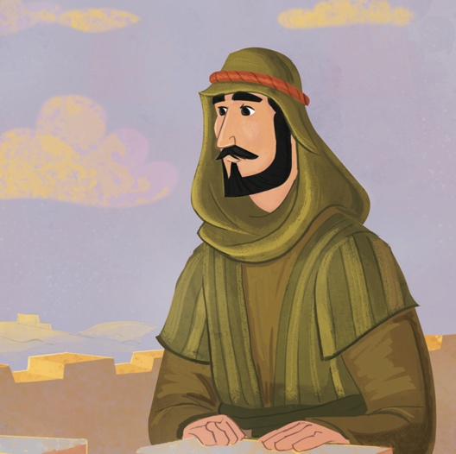
All About Habakkuk

Read Habakkuk 1:2-3. What problem does he have that he is telling to God?
_____________________________________________________________________________________
_____________________________________________________________________________________
_____________________________________________________________________________________

What is Habakkuk’s second complaint in Habakkuk 1:13?
_____________________________________________________________________________________
_____________________________________________________________________________________
_____________________________________________________________________________________

Habakkuk was honest with God about his questions and struggles, but he still made the choice to worship. Read Habakkuk 3:17-18. Write a modern-day version of Habakkuk’s words for how you would worship God even in the hard times.

Read Habakkuk 3:19. Who does Habakkuk say is his strength?
_____________________________________________________________________________________
_____________________________________________________________________________________
_____________________________________________________________________________________

Troubled times WILL come. However, in those hardships we have the opportunity to still choose to worship God. We can’t do it on our own; we must rely on the Sovereign Lord as our strength. Through Him, we can worship even when life hits rock-bottom.

Pray that God would give you strength to worship Him when everything falls apart.

Review
Use this review to test the things you’ve learned from this first lesson! If you can’t remember, look back at the last couple of pages!

Fill in the blank- worship is a….
_____________________________________________________________________________________

What happened after Paul and Silas worshipped God while in prison?
_____________________________________________________________________________________
_____________________________________________________________________________________
_____________________________________________________________________________________

Who was Habakkuk?
_____________________________________________________________________________________
_____________________________________________________________________________________
_____________________________________________________________________________________

Who did Habakkuk say was his strength?
_____________________________________________________________________________________
_____________________________________________________________________________________
_____________________________________________________________________________________

Spend some time actually worshipping God in the midst of whatever you are going through right now. Choose to praise God through song or prayer whether you’re having a great day or an awful day.

Lesson 4

Goals
- Learn the importance of repentance in our walk with God

Repentance
As we talked about before, worship is a choice; we must choose to continue to praise God even in the hard times. However, worship does not mean that we refuse to acknowledge things that are wrong in our lives. There is a place for brokenness and repentance in our discipleship relationship with God. There comes a time when we realize that our attitudes have not always been right. Our worship has become tainted.
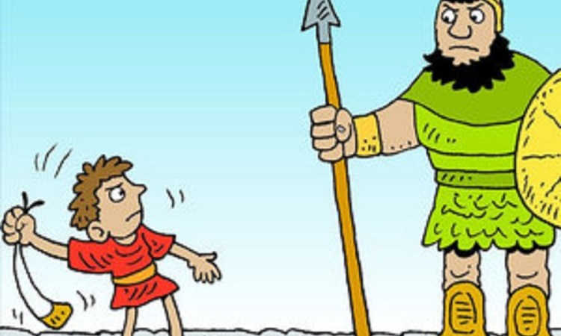
One example of repentance is in the life of David. Who was David? Without looking at the Bible or other resources, write down below everything you know about David.

Read 2 Samuel 11:2-5. What sin did David commit?
_____________________________________________________________________________________
_____________________________________________________________________________________
_____________________________________________________________________________________

Read 2 Samuel 11:14-17. What did David do to Uriah?
_____________________________________________________________________________________
_____________________________________________________________________________________
_____________________________________________________________________________________

Clearly, David sinned in multiple ways. After Nathan confronted him about his sin, David spent time repenting, which is recorded in Psalm 51. Repenting means to turn away from our sin. When we repent, we ask God to forgive us and we commit to trying to not do the same thing again. Read Psalm 51:1-12 and write below all the words David uses that show his repentance before God.

David came to realize how he had sinned and offended God. He saw that his heart was wrong and that he acted in evil ways, so he repented. Another person to look at is the prophet Isaiah. Let’s look at his commission to be God’s messenger to His people.

Read Isaiah 6:1-4. What does Isaiah see?
_____________________________________________________________________________________
_____________________________________________________________________________________
_____________________________________________________________________________________

Draw a picture below of what you think Isaiah was looking at- what a glorious sight!

Read Isaiah 6:5. In response to what Isaiah sees, what does he say?
_____________________________________________________________________________________
_____________________________________________________________________________________
_____________________________________________________________________________________

When Isaiah saw God, he recognized God’s greatness, power, and holiness. Seeing God’s awesomeness made him recognize his own sinfulness before God. So, he confessed. Isaiah’s example encourages us to confess our sin as well.

What happens when Isaiah confesses his sin? Read Isaiah 6:6-7 to find out, and record your findings below.
_____________________________________________________________________________________
_____________________________________________________________________________________
_____________________________________________________________________________________

When Isaiah repented, his sins were forgiven. This should be extremely comforting for us! Like Isaiah, we can see God’s greatness through the words of Scripture and through His work in our own lives. Looking to God reminds us of how sinful we are, which leads us to repent. AND, when we repent the Lord is faithful to forgive us our sins. Praise God!

We all have sinned and fall short of God’s glory. What things would you like to confess to God today? Take some time to remember God’s greatness; then confess your sins and receive God’s forgiveness!

Review
Use this review to test the things you’ve learned from this first lesson! If you can’t remember, look back at the last couple of pages!

What does repentance mean?
_____________________________________________________________________________________
_____________________________________________________________________________________
_____________________________________________________________________________________

What sins did David commit, and how did he eventually respond to them?
_____________________________________________________________________________________
_____________________________________________________________________________________
_____________________________________________________________________________________

What are a few of the things Isaiah saw in Isaiah 6?
_____________________________________________________________________________________
_____________________________________________________________________________________
_____________________________________________________________________________________

What happened to Isaiah after he confessed his uncleanness?
_____________________________________________________________________________________
_____________________________________________________________________________________
_____________________________________________________________________________________

Lesson 5

Goal
- See an example of undignified worship

Undignified Worship
Last lesson we looked a little bit into the life of David, and today we are going to do so even more! An interesting story from his life is in 2 Samuel 6, where David brings the Ark of the Covenant into the capital city of Jerusalem.

What do you know about the Ark of the Covenant? Below, write everything you know about it. Or, if you don’t know anything, ask your parents to tell what they know!
The Ark of the Covenant:

Now look in Exodus 25:10-22 at a description of the Ark of the Covenant. Draw a picture below of what you think this would have looked like based off this passage of Scripture!!

Now look specifically in Exodus 25:14. What specific instruction does this say about the ark of the covenant?
_____________________________________________________________________________________
_____________________________________________________________________________________
_____________________________________________________________________________________

In 1 Chronicles 15:2, what instruction does David give about carrying the Ark?
_____________________________________________________________________________________
_____________________________________________________________________________________
_____________________________________________________________________________________
Now let’s get back to the actual story. Read 2 Samuel 6:1-7. Based on the previous verses you’ve looked at, what did David and his men do right in these verses? What did they do wrong?
Right: Wrong:

Read 2 Sam. 6:13-15 and 17-19. What was David doing as he brought the Ark into the city?
_____________________________________________________________________________________
_____________________________________________________________________________________
_____________________________________________________________________________________
_____________________________________________________________________________________
_____________________________________________________________________________________
_____________________________________________________________________________________

Read 2 Sam. 6:16 and 20. How did Michal react to David?
_____________________________________________________________________________________
_____________________________________________________________________________________
_____________________________________________________________________________________
_____________________________________________________________________________________
_____________________________________________________________________________________

Read 2 Samuel 6:21-22. How does David respond to Michal?
_____________________________________________________________________________________
_____________________________________________________________________________________
_____________________________________________________________________________________
_____________________________________________________________________________________

David is not a perfect example in these verses; as we saw in the early verses he didn’t follow all of God’s standards for how the Ark should be carried. However, something he did get right was undignified worship. He didn’t care about what other’s thought about him because he knew it only mattered what God thought. Michal’s problem was that she didn’t understand that true worship abandons self completely and focuses on God entirely. David understood that God is so amazing that we should be overjoyed to worship him! Our worship should be extravagant because He is!

Like David, we are not perfect worshippers. We need God’s grace to help us follow him. However, we should follow God’s example and live lives of undignified worship for the glory of God!

Take some time to worship God in an undignified way! Sing, dance, shout, and fully abandon yourself while totally giving God the glory. He delights when we do this!
Review
Use this review to test the things you’ve learned from this first lesson! If you can’t remember, look back at the last couple of pages!

What was the Ark of the Covenant?
_____________________________________________________________________________________
_____________________________________________________________________________________
_____________________________________________________________________________________

How was the Ark supposed to be carried, and how did David transport it?
_____________________________________________________________________________________
_____________________________________________________________________________________

How did David worship God? What did he do?
_____________________________________________________________________________________
_____________________________________________________________________________________
_____________________________________________________________________________________

What word did David use to describe his worship?
_____________________________________________________________________________________

What did Michal think of David’s worship?
_____________________________________________________________________________________
_____________________________________________________________________________________
_____________________________________________________________________________________

Lesson 6

Goal
- Understand the role of the Holy Spirit in our worship

Worshipping in Spirit and Truth
God is a Triune God. He is three distinct persons but yet fully one God- this is one of the great beauties and mysteries of the Bible. The Trinity consists of the Father, the Son, and the Holy Spirit. The Holy Spirit is often the least talked-about Person of the Trinity. What do you know about the Holy Spirit? Write down what you know below before we look at what the Bible has to say.
The Holy Spirit

Read the following verses and record what they have to say about the Holy Spirit.

John 14:15-17
_____________________________________________________________________________________
_____________________________________________________________________________________

John 14:26
_____________________________________________________________________________________
_____________________________________________________________________________________

Romans 8:14
_____________________________________________________________________________________
_____________________________________________________________________________________

Romans 8:26
_____________________________________________________________________________________
_____________________________________________________________________________________

1 Corinthians 3:16-17
_____________________________________________________________________________________
_____________________________________________________________________________________

2 Corinthians 3:17-18
_____________________________________________________________________________________
_____________________________________________________________________________________

Now let’s key in on one specific verse. In John 4, Jesus is talking to a Samaritan woman and begins to talk about what proper worship looks like. Read John 4:23-24. What does Jesus say true worship looks like?
_____________________________________________________________________________________
_____________________________________________________________________________________

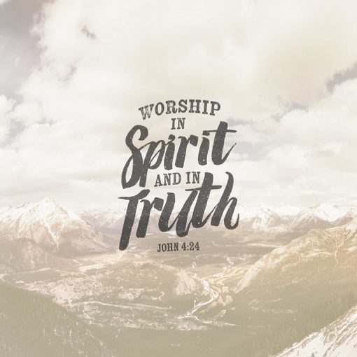
This passage says many powerful things, but one important thing to notice is that God is seeking people who will worship Him in the Spirit and in truth. He is actively looking for people who will respond to the
Spirit and worship according to the truths that have been revealed to them. Dependence on the Holy Spirit is the key to all authentic lifestyle worship.

The Holy Spirit is the worship leader of our lives. He helps us to know truths about God that can only be revealed by spiritual means. He guides us into relationship with God that we cannot fathom on our own.

There is nothing more amazing than when the Holy Spirit interrupts our normal lives and breathes new life into us. It is an unpredictable. One example of such a worship event it in Mark 14.

Read Mark 14:1-2. What are the circumstances surrounding Jesus in this story?
_____________________________________________________________________________________
_____________________________________________________________________________________
_____________________________________________________________________________________

Read Mark 14:3. What does the woman do?
_____________________________________________________________________________________
_____________________________________________________________________________________
_____________________________________________________________________________________

Read Mark 14:4-5. How did those who were there respond to the woman?
_____________________________________________________________________________________
_____________________________________________________________________________________
_____________________________________________________________________________________

Finally, read Mark 14:6-9. How does Jesus respond to the woman?
_____________________________________________________________________________________
_____________________________________________________________________________________
_____________________________________________________________________________________

This chapter shows how different people respond to Jesus. The religious leaders hate Jesus and are plotting his death. However, the woman recognized Jesus as the Messiah and spontaneously worshipped at His feet. She responded in the right way, the others did not.

Pray that the Holy Spirit would guide you into true worship. Then, be attentive to the Spirit’s promptings in your life and rely on Him. At those times, don’t be afraid to give God the praise He deserves!

Review
Use this review to test the things you’ve learned from this first lesson! If you can’t remember, look back at the last couple of pages!

What do you now know about the Holy Spirit?
_____________________________________________________________________________________
_____________________________________________________________________________________
_____________________________________________________________________________________

What type of people is God seeking?
_____________________________________________________________________________________
_____________________________________________________________________________________

Who is the worship leader of our lives?
_____________________________________________________________________________________

Who was a good example of worshipping in Spirit and truth from Mark 14? Who was a bad example?
_____________________________________________________________________________________
_____________________________________________________________________________________
_____________________________________________________________________________________

Lesson 7

Goal
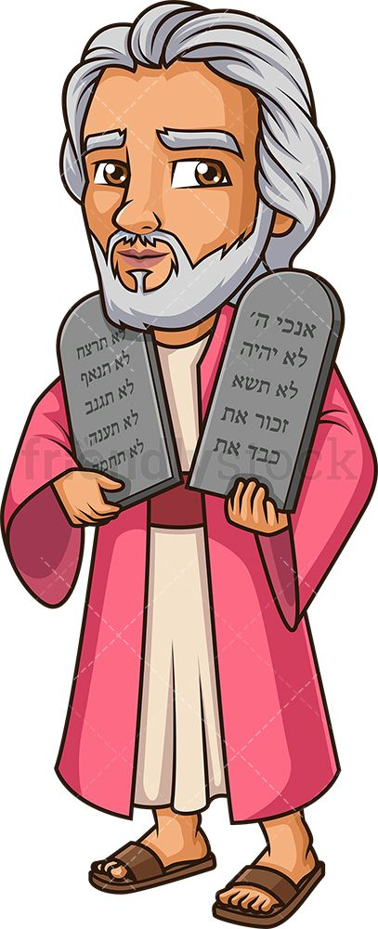
- Become an unveiled worshipper

Unveiled Worship
A great story about an encounter with God is in Exodus 34. God was beginning to reveal His character and standards through giving the law to Moses. What do you know about Moses? Write below everything you know about this important man in the Bible.

All About Moses:

Read Exodus 34:29-32. What happened to Moses’ face? Why did this happen?
_____________________________________________________________________________________
_____________________________________________________________________________________
_____________________________________________________________________________________

Read Exodus 34:33-35. What would Moses do when he was speaking to the people? Why do you think he did this?
_____________________________________________________________________________________
_____________________________________________________________________________________
_____________________________________________________________________________________

Moses’ face needed to be veiled to separate the people of Israel from the glory of God. This is because God’s glory was so great! This was not the only place where we see God’s glory being veiled in the Old Testament. Read Leviticus 16:2 and write what you learn about a curtain protecting people from God’s glory.
_____________________________________________________________________________________
_____________________________________________________________________________________
_____________________________________________________________________________________

Only the high priest behind the veil of the tabernacle, and he could only do so one day a year at the appointed time. At this time, he would make an offering to atone for the sins of God’s people.
In the New Testament, we see Jesus described as the High Priest who went behind the veil once and for all.

Read Matthew 25:50-52. What happened to the temple veil when Jesus died?
_____________________________________________________________________________________
_____________________________________________________________________________________
When Jesus was crucified, the veil of the temple was torn in two. This symbolized that God’s presence was being opened to all believers. Before, only appointed people could be in God’s presence at the appointed time, but through Jesus we are able to access God’s glory unveiled. Paul talks about this more in 2 Corinthians 3.

Read 2 Corinthians 3:7. What is the “ministry that brought death?” Think back to our previous story about Moses.
_____________________________________________________________________________________
_____________________________________________________________________________________
_____________________________________________________________________________________

Read 2 Corinthians 3:8-11. Paul is comparing the Old Covenant that God made with Israel with the New Covenant God makes with us through Jesus. Here, he calls the new covenant the “ministry of the Spirit.” How does Paul describe the New Covenant compared to the Old Covenant?
_____________________________________________________________________________________
_____________________________________________________________________________________
_____________________________________________________________________________________

Because of the New Covenant through Jesus, how are we to act according to 2 Corinthians 3:12?
_____________________________________________________________________________________
_____________________________________________________________________________________

Read 2 Corinthians 3:13-16. How is the veil removed according to these verses?
_____________________________________________________________________________________
_____________________________________________________________________________________
_____________________________________________________________________________________
Finally, read 2 Corinthians 3:17-18. Compared to Moses, what type of faces do we have? As we experience God’s glory and His presence, what happens to us?
_____________________________________________________________________________________
_____________________________________________________________________________________
_____________________________________________________________________________________
_____________________________________________________________________________________
_____________________________________________________________________________________

Paul is saying a lot here, so let’s summarize. Paul is saying that the law in the old covenant was great, but the new covenant is even greater. Moses had to veil his face after he had been in God’s presence. But now because of Jesus, the veil is lifted when anyone becomes a Christian, giving us eternal life, freedom from the law, and access to a personal relationship with God. We get to be unveiled worshippers, being in His presence and worshipping Him through the Spirit. As we do so, God transforms us more to be like Him!

In response to how God has allowed us to be in relationship with Him, we should be grateful! Unlike the Israelites, we can experience God and worship Him in a new way. Spend some time thanking God for removing the veil and allowing you to be an unveiled worshipper. Then spend some time praising Him!

Review
Use this review to test the things you’ve learned from this first lesson! If you can’t remember, look back at the last couple of pages!

Who was Moses?
_____________________________________________________________________________________
_____________________________________________________________________________________
_____________________________________________________________________________________

When Moses was with God, what happened to his face? What did he have to do?
_____________________________________________________________________________________
_____________________________________________________________________________________
_____________________________________________________________________________________

What happened to the temple veil when Jesus died?
_____________________________________________________________________________________

How are we different from Moses and Israel in our ability to be in relationship with God?
_____________________________________________________________________________________
_____________________________________________________________________________________
_____________________________________________________________________________________
_____________________________________________________________________________________
_____________________________________________________________________________________

Overview
Congratulations! You made it through this study on worship! Let’s take some time to reflect on what we’ve learned. Feel free to look back at the previous lessons for help!

What is worship?
_____________________________________________________________________________________
_____________________________________________________________________________________
_____________________________________________________________________________________

What type of attitude do worshippers have?
_____________________________________________________________________________________
_____________________________________________________________________________________
_____________________________________________________________________________________

A lifestyle of worship is a _______________

What does it mean to repent?
_____________________________________________________________________________________
_____________________________________________________________________________________
_____________________________________________________________________________________

What good things did David do in his worship of God that are an example for us?
_____________________________________________________________________________________
_____________________________________________________________________________________
_____________________________________________________________________________________
What type of people is God seeking?
_____________________________________________________________________________________
_____________________________________________________________________________________
_____________________________________________________________________________________

Who is the worship leader of our lives?
_____________________________________________________________________________________
_____________________________________________________________________________________
_____________________________________________________________________________________

What is the difference between how Moses experienced God’s glory and how we are able to experience His glory?
_____________________________________________________________________________________
_____________________________________________________________________________________
_____________________________________________________________________________________

Thanks for doing this study and diving into God’s Word to learn more about worship. Now, don’t just let all you’ve learned be quickly forgotten. Take what you’ve learned and put it into practice! Take time to not just worship God in church but also worship him in your everyday life through song, prayer, service, and how you live. Devote yourself to Him wholeheartedly, and live a life that worships Him with an undivided heart!

