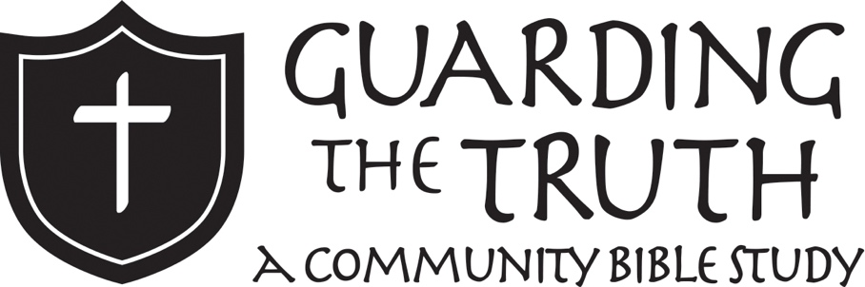
How To Study
The Bible
FOR KIDS

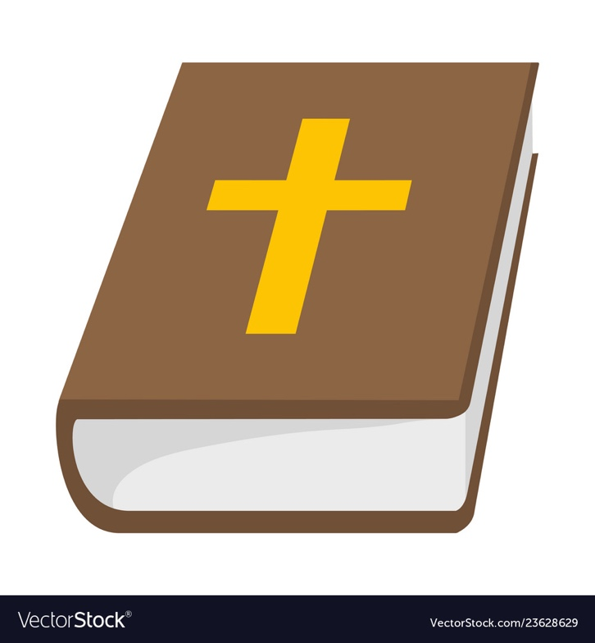

Lesson 1

Goals
- Understand what languages the Bible was originally written in
- Learn the reasons there are different English translations and what differentiates them
- Be introduced to helpful Bible study tools
- See the process of doing an inductive Bible study
The Basics
The Bible is composed of 66 books. These books were not originally written in English! The Old Testament was written in Hebrew. Hebrew actually reads from right to left instead of left to right! Here is a what Genesis 1:1 looks like in Hebrew: to you recognize it?

בְּרֵאשִׁ֖ית בָּרָ֣א אֱלֹהִ֑ים אֵ֥ת הַשָּׁמַ֖יִם וְאֵ֥ת הָאָֽרֶץ

The New Testament was written in Greek. Here is what John 3:16 looks like in Greek;

ὕτως γὰρ ἠγάπησεν ὁ θεὸς τὸν κόσμον, ὥστε τὸν υἱὸν τὸν μονογενῆ ἔδωκεν, ἵνα πᾶς ὁ πιστεύων εἰς αὐτὸν μὴ ἀπόληται ἀλλ᾿ ἔχῃ ζωὴν αἰώνιον.

Since the Bible was originally written in Greek and Hebrew, over the years people have had to translate it into English. Here’s some examples of some English translations of John 17:4. Underline the differences between them!

New International Version
I have brought you glory on earth by finishing the work you gave me to do.
New Living Translation
I brought glory to you here on earth by completing the work you gave me to do.
English Standard Version
I glorified you on earth, having accomplished the work that you gave me to do.
Since each English version of the Bible is a translation, translators have to make choices about how to translate words. People have not always agreed on the best way to translate the text because there are a lot of verses that are hard to translate from the original language! Some things are hard to understand once it is in English, and figuring out how to say it in English can be very hard. This is why we have different translations.

Translation Theory
1. Literal: translate hard phrases literally and let the reader decide what the author meant
Example: translating “holy kiss” as “holy kiss”
2. Dynamic Equivalent: translate the word or phrase with a word or phrase that is essentially equivalent in our culture
Example: translating “holy kiss” as “handshake”
3. Paraphrase: translate the basic idea into our language without staying closely tied to the original words so it sounds more modern
Example: translating “holy kiss” as “Holy embraces all around!”

Bible Study Tools
In order to study the Bible well, it can be helpful to use Bible study tools! In our day, there are so many great resources out there. Here are a few examples to get you started!

Concordance: Alphabetical listing of words in the Bible and what passages they appear in
Example: The New Strong’s Exhaustive Concordance of the Bible

Bible Dictionaries: Alphabetical listing of words in the Bible and their definition
Example: New Bible Dictionary

Bible Atlas: a book of maps and charts of places in the Bible
Example: The Moody Atlas of Bible Lands

Bible Study Definitions
Exegesis: to bring out meaning of the biblical text
Hermeneutics: to interpret what the text meant originally
Application: applying the text to our lives today
Inductive Study: a phrase for the whole process of exegesis, hermeneutics, and application
General Revelation: what God has revealed to us through the natural world
Special Revelation: what God has revealed to us through His Word

Inductive Bible Study
PRAYER: ask God by His Spirit to lead you into all truth
OBSERVATION: (exegesis) What does this passage say?
INTERPRETATION: (hermeneutics) What does this passage mean?
APPLICATION: How does the meaning of this passage apply to me?

Review
Use this review to test the things you’ve learned from this first lesson! If you can’t remember, look back at the last couple of pages!

What language was the Old Testament originally written in?

What language was the New Testament originally written in?

What are the three different translation theories?

What is one helpful Bible study tool?

What is the difference between general revelation and special revelation?

After prayer, what are the three steps to inductive Bible study?

Lesson 2

Goals
- Learn helpful questions to ask when studying the Bible
- Practice Biblical Curiosity through asking good questions of the text
- Write a one-sentence summary of the passage

Biblical Curiosity
When we study the Bible, it’s important to be curious. If we ask good questions, we are able to dig deeper into the text. Answers to these questions help us understand the Bible better and better. When asking questions ask who, what, where, when, why, and how.
Who
Is the author and recipients?
Is mentioned in the passage?
What
Kind of book is it (story, letter, etc…)?
Is happening/said in this passage?
Is the meaning of this passage?
When
Was it written?
Where
Are the places mentioned in the book?
Why
Was the story/passage originally written?
How
Does this fit into the greater story of the Bible?
Does this apply to my life?
Some of the answers to these questions can be found in the book itself. Other times, this information can be found in the page at the front of the book in the Bible. If these don’t give the answers, do research online to find the answers!

Biblical Curiosity Practice
As an example, let’s look at the book of Philemon. This is a good book to practice with because it is only one chapter! Turn to Philemon in your Bible. Read all 25 verses, then answer the following questions.

Who is the author? (verse 1)
_____________________________________________________________________________________
_____________________________________________________________________________________

Who is the book written to? (verses 1-2)
_____________________________________________________________________________________
_____________________________________________________________________________________

Who else is mentioned in the passage? (verses 10, 23-24)
_____________________________________________________________________________________
_____________________________________________________________________________________
_____________________________________________________________________________________

What kind of book is it (story, letter, poetry, etc…)?
_____________________________________________________________________________________

What is happening/said in this passage? (verses 8-10, 14)
_____________________________________________________________________________________
_____________________________________________________________________________________
_____________________________________________________________________________________
What is the meaning of this passage? (Look at the whole passage)
_____________________________________________________________________________________
_____________________________________________________________________________________
_____________________________________________________________________________________

When was it written? (check your Bible or an online source)
_____________________________________________________________________________________
_____________________________________________________________________________________

Where are the places mentioned in the book? (check your Bible or an online source to see where Paul likely was and where Philemon lived)
_____________________________________________________________________________________
_____________________________________________________________________________________
_____________________________________________________________________________________
_____________________________________________________________________________________

Why was the passage originally written? (verses 10, 17)
_____________________________________________________________________________________
_____________________________________________________________________________________
_____________________________________________________________________________________

How does this fit into the greater story of the Bible? (how does this show God’s heart and how Christians are supposed to live?)
_____________________________________________________________________________________
_____________________________________________________________________________________
_____________________________________________________________________________________
_____________________________________________________________________________________

How does this apply to my life? (think about how this passage might translate to your life)
_____________________________________________________________________________________
_____________________________________________________________________________________
_____________________________________________________________________________________
_____________________________________________________________________________________
_____________________________________________________________________________________
_____________________________________________________________________________________

One-Sentence Summary
Great job! You successfully studied the Bible through asking good questions. When you’ve studied a passage of Scripture, it’s often helpful to write a one-sentence summary to remember what you learned. Another name for this is a “permanent principle” since it’s an idea from the Bible that lasts no matter where or when it is brought up.
Write one sentence summarizing what you have read and learned from spending some time in Philemon. As you continue reading the Bible and studying Scripture, write these summaries in your Bible or in a journal.
_____________________________________________________________________________________
_____________________________________________________________________________________
_____________________________________________________________________________________
_____________________________________________________________________________________

Lesson 3
Goals
- Learn how to paraphrase
- Practice paraphrasing well-known Bible verses

Paraphrasing
Another helpful skill to learn in studying the Bible is paraphrasing. Paraphrasing is taking what the Bible says and putting it in your own words. Though it is your own words, it should still carry the same overall ideas and meaning as the Scripture itself.

As an example, let’s take 1 Corinthians 6:19-20. The passage says this:
Or do you not know that your body is a temple of the Holy Spirit who is in you, whom you have from God, and that you are not your own? For you have been bought with a price: therefore, glorify God in your
body.

Here is what a paraphrase of this passage might look like:
When you accepted Christ, the Holy Spirit came to live in your body, sent by the Father. Therefore, your body does not belong to you; you were redeemed from sin at great cost by the Jesus. So, use your body not to sin, but to praise God.

See how easy that is! Just take what the Bible says and use your own words while still keeping the same overall point of the passage. When you do this, make sure to look first at the words of Scripture and to paraphrase from those words instead of just saying whatever you want to say.
Paraphrasing Practice
Let’s take some common passages in Scripture and practice paraphrasing them! Use your own words, but keep the original intent of the passage.

Gen. 1:1 In the beginning, God created the heavens and the earth.
_____________________________________________________________________________________
_____________________________________________________________________________________

Lev. 19:18 You shall not take vengeance or bear a grudge against the sons of your own people, but you shall love your neighbor as yourself: I am the LORD.
_____________________________________________________________________________________
_____________________________________________________________________________________

Josh. 1:9 Have I not commanded you? Be strong and courageous. Do not be frightened, and do not be dismayed, for the LORD your God is with you wherever you go.”
_____________________________________________________________________________________
_____________________________________________________________________________________
_____________________________________________________________________________________
_____________________________________________________________________________________

John 3:16 For God so loved the world, that he gave his only Son, that whoever believes in him should not perish but have eternal life.
_____________________________________________________________________________________
_____________________________________________________________________________________
_____________________________________________________________________________________
_____________________________________________________________________________________
Matt. 28:19 Go therefore and make disciples of all nations, baptizing them in the name of the Father and of the Son and of the Holy Spirit,
_____________________________________________________________________________________
_____________________________________________________________________________________
_____________________________________________________________________________________
_____________________________________________________________________________________

Rom. 8:28 And we know that for those who love God all things work together for good, for those who are called according to his purpose.
_____________________________________________________________________________________
_____________________________________________________________________________________
_____________________________________________________________________________________
_____________________________________________________________________________________

James 1:22 But be doers of the word, and not hearers only, deceiving yourselves.
_____________________________________________________________________________________
_____________________________________________________________________________________

Phil. 4:13 I can do all things through him who strengthens me.
_____________________________________________________________________________________
_____________________________________________________________________________________

Great job! You’re becoming an expert paraphraser! We’ve been paraphrasing just one verse at a time, but the next level is to paraphrase a larger passage. On the next page is a bigger passage with three verses. Paraphrase this entire passage, going sentence by sentence. This will be a challenge, but you can do it!

Hebrews 12:1-3 Therefore, since we are surrounded by so great a cloud of witnesses, let us also lay aside every weight, and sin which clings so closely, and let us run with endurance the race that is set before us, looking to Jesus, the founder and perfecter of our faith, who for the joy that was set before him endured the cross, despising the shame, and is seated at the right hand of the throne of God. Consider him who endured from sinners such hostility against himself, so that you may not grow weary or fainthearted.
_____________________________________________________________________________________
_____________________________________________________________________________________
_____________________________________________________________________________________
_____________________________________________________________________________________
_____________________________________________________________________________________
_____________________________________________________________________________________
_____________________________________________________________________________________
_____________________________________________________________________________________
_____________________________________________________________________________________
_____________________________________________________________________________________
_____________________________________________________________________________________
_____________________________________________________________________________________

Now, to practice something we learned in the last lesson, write a one-sentence summary of this passage!
_____________________________________________________________________________________
_____________________________________________________________________________________
_____________________________________________________________________________________
_____________________________________________________________________________________
_____________________________________________________________________________________
Lesson 4

Goals
- Learn the types of cross-references
- Practice looking up cross-references

Cross-Referencing
Another great thing to do in studying the Bible is cross-referencing. Cross-referencing is looking at other passages that are related to the passage of Scripture that you are studying.

One type of cross-reference is a quotation, a verse cited from elsewhere in the Bible. An example of this is James 2:8:
“If you really fulfill the royal law according to the Scripture, ‘You shall love your neighbor as yourself,’ you are doing well.”

In this verse, James quotes another verse from Scripture. He quotes Leviticus 19:18, which says, “You shall not take vengeance or bear a grudge against the sons of your own people, but you shall love your neighbor as yourself: I am the LORD.” James’ quote is an exact quote cited from Leviticus.

Another type of cross-reference is a similarity. Sometimes, Bibles show verses that are very similar to the verse you are studying so that you can go and look at that similar verse. An example of this is Colossians 3:1:
“If then you have been raised with Christ, seek the things that are above, where Christ is, ^{d}seated at the right hand of God.”

Notice the small “d” in front of the word “seated.” This is a cross-reference to look at Ephesians 1:20, which says, “that he worked in Christ when he raised him from the dead and seated him at his right hand in the heavenly places.”
Notice that these verses are similar because in both places Paul is talking about Jesus being seated at God’s right hand. Though it’s not an exact quote, these verses are connected through their words and themes.

Cross-Reference Practice
Let’s practice some cross-referencing! I will provide a verse with its cross-references. Look up the cross-references and write it it’s a quote or a similarity. It it’s a quote, write the original verse. If it’s a similarity, write what is similar.

Mark 1:2-3 As it is written in Isaiah the prophet, ^{c}“Behold, I send my messenger before your face, who will prepare your way, ^{d}the voice of one crying in the wilderness: ‘Prepare the way of the Lord, make his paths straight,’”
c- Mal. 3:1
d- Isa. 40:3
_____________________________________________________________________________________
_____________________________________________________________________________________
_____________________________________________________________________________________
_____________________________________________________________________________________

John 6:31 Our fathers ate the manna in the wilderness; as it is written, ^{u}‘He gave them bread from heaven to eat.’”
u- Neh. 9:15
_____________________________________________________________________________________
_____________________________________________________________________________________
_____________________________________________________________________________________

Acts 1:9 And when he had said these things, as they were looking on, the was lifted up, and ^{u}a cloud took him out of their sight.
u- 1 Thess. 4:17
_____________________________________________________________________________________
_____________________________________________________________________________________

Acts 7:42 But ^{j}God turned away and gave them over to worship the host of heaven, as it is written in the book of the prophets: ^{m}“‘Did you bring to me slain beasts and sacrifices, during the forty years in the wilderness, O house of Israel?
j- Josh. 24:20
m- Amos 5:25-27
_____________________________________________________________________________________
_____________________________________________________________________________________
_____________________________________________________________________________________

Rom. 1:3 concerning his Son, ^{f}who was descended from David ^{g}according to the flesh
f- Matt. 1:1
g- Gal. 4:4
_____________________________________________________________________________________
_____________________________________________________________________________________
_____________________________________________________________________________________

Rom. 8:36 As it is written, ^{w}“For your sake we are being killed all the day long; we are regarded as sheep to be slaughtered.”
w- Ps. 44:22
_____________________________________________________________________________________
_____________________________________________________________________________________
_____________________________________________________________________________________

Col. 1:1 Paul, ªan apostle of Christ Jesus ^{b}by the will of God, and Timothy ^{c}our brother,
a- 2 Cor. 1:1
b- 1 Cor. 1:1
c- 1 Thess. 3:2
_____________________________________________________________________________________
_____________________________________________________________________________________
_____________________________________________________________________________________

Col. 2:7 ^{i}rooted and ^{j}built up in him and ^{k}established in the faith, just ^{l}as you were taught, abounding ^{m}in thanksgiving.
i- Eph. 3:17
j- 1 Cor 3:9
k- Heb. 13:9
l- Eph. 4:21
m- Eph. 5:20
_____________________________________________________________________________________
_____________________________________________________________________________________
_____________________________________________________________________________________
_____________________________________________________________________________________
_____________________________________________________________________________________
_____________________________________________________________________________________

Isn’t it awesome to see how interconnected the Bible is?! The Bible is SO COOL!!! New Testament authors quote and allude to the Old Testament all the time. Verses all over the Scriptures have the same themes because there is a beautiful unity in the Bible. Cross-referencing helps our personal study of individual passages and also connects us to God’s greater narrative in all of Scripture.
Lesson 5

Goals
- Learn how to do an Inductive Bible Study
- Practice the Inductive Bible Study method

Inductive Bible Study
Now that you’ve learned some helpful tools in studying the Bible, let’s see how to do an Inductive Bible Study! We mentioned this earlier, but here we will dive in deeper. Here are the steps to this method:

PRAYER: Always begin your time of Bible study in prayer. Ask God to illuminate the text to you through His Holy Spirit. Be attentive to what God might be speaking in your heart. To honor God, be attentive to the text as well.

OBSERVATION: This step is also known as exegesis, which is bringing things out of a passage. What does this passage say? If it’s a story, what is happening here? Use your “Biblical Curiosity” questions to observe the text well. Look at cross-references for more insight.
INTERPRETATION: This is also known as hermeneutics. In interpretation we ask ourselves this question: What does this passage mean? Helpful tools in interpretation are paraphrasing and writing one-sentence summaries to see what the passage intends to convey.

APPLICATION: Finally, we connect the text to our lives. We ask this question: How does the meaning of this passage apply to me? How does it apply in my season of life? In my location? In my social circles?

Now let’s look at an example of an Inductive Bible Study. Turn to Mark 2:1-12 and let’s go through the steps to study this passage together.

PRAYER: Lord thank you for this passage of Scripture that You have given us. Please speak to us through the reading and studying of this text. Open our eyes to look into Mark 2, and also open our eyes to what you might be speaking into our lives. In Jesus’ name, Amen.

OBSERVATION: Below is the passage Mark 2:1-12.

¹And when he returned to Capernaum after some days, it was reported that he was at home. ² And many were gathered together, so that there was no more room, not even at the door. And he was preaching the word to them. ³ And they came, bringing to him a paralytic carried by four men.⁴ And when they could not get near him because of the crowd, they removed the roof above him, and when they had made an opening, they let down the bed on which the paralytic lay. ⁵ And when Jesus saw their faith, he said to the paralytic, “Son, your sins are forgiven.” ⁶ Now some of the scribes were sitting there, questioning in their hearts, ⁷ “Why does this man speak like that? He is blaspheming! Who can forgive sins but God alone?”⁸ And immediately Jesus, perceiving in his spirit that they thus questioned within themselves, said to them, “Why do you question these things in your hearts? ⁹ Which is easier, to say to the paralytic, ‘Your sins are forgiven,’ or to say, ‘Rise, take up your bed and walk’? ¹⁰ But that you may know that the Son of Man has authority on earth to forgive sins”—he said to the paralytic— ¹¹ “I say to you, rise, pick up your bed, and go home.” ¹² And he rose and immediately picked up his bed and went out before them all, so that they were all amazed and glorified God, saying, “We never saw anything like this!”

Who is the author?- Mark

Who is mentioned? - Jesus, the crowd, a paralytic, men carrying the paralytic, scribes
What kind of book is it?- a gospel. A narrative about Jesus.

What is happening/said in this passage? - Jesus is teaching a crowd, when men bring a paralytic to him through the extreme measures of going through the roof. Jesus sees that they have faith, and he forgives the paralytic of his sins. Jesus addresses the scribes and proves that He has the authority to forgive sins through his healing of the man’s paralysis. Everyone is amazed!!

When was it written? - sometime in the first century.

Where are the places mentioned in the passage? - Capernaum, a home with a roof and door.

Why was the passage originally written? - to show Jesus doing a miracle and forgiving someone of their sins

Important Cross Reference: Psalm 32:5 and Isaiah 43:25 show why the scribes would be thinking Jesus is blaspheming in Mark 2:7. Only God could forgive sins, so the religious leaders were concerned because Jesus was essentially claiming to be God.
INTERPRETATION: This is also known as hermeneutics. In interpretation we ask ourselves this question: What does this passage mean? Helpful tools in interpretation are paraphrasing and writing one-sentence summaries to see what the passage intends to convey.

What is the meaning of this passage? - The meaning is Jesus has the authority to meet our ultimate need for forgiveness. The man has a physical need in healing, and Jesus heals him physically but points him to his greater spiritual need for forgiveness.

How does this fit into the greater story of the Bible? - this is the beginning of Jesus’ ministry. Jesus forgives this man of his sin and heals him. Through Jesus’ life, death, resurrection, and ascension he will make a way for the forgiveness of sins for everyone in the world.

One-Sentence Summary: Jesus has the authority to meet our ultimate need for the forgiveness of our sins.

APPLICATION: Finally, we connect the text to our lives. We ask this question: How does the meaning of this passage apply to me? How does it apply in my season of life? In my location? In my social circles?

How does this apply to my life? - Like the men who brought the paralytic, I should have faith in Jesus that is shown through my actions. I should recognize that Jesus has been given the authority to forgive sins because He is God. Therefore, I should confess my sins to Him and receive His forgiveness.

Inductive Bible Study Practice
Now do your own inductive Bible study! If you want to work through another story, go to 1 Kings 18:16-46. If you want to work through a letter, go to James 1:19-27. Use the space below to guide you through the text. Write down your thoughts in each step. Utilize the tools you have learned such as question asking, paraphrasing, one-sentence summaries, and even see if there are any helpful cross-references to look up!

PRAYER: Always begin your time of Bible study in prayer. Ask God to illuminate the text to you through His Holy Spirit. Be attentive to what God might be speaking in your heart. To honor God, be attentive to the text as well.

OBSERVATION: This step is also known as exegesis, which is bringing things out of a passage. What does this passage say? If it’s a story, what is happening here? Use your “Biblical Curiosity” questions to observe the text well. Look at cross-references for more insight.

INTERPRETATION: This is also known as hermeneutics. In interpretation we ask ourselves this question: What does this passage mean? Helpful tools in interpretation are paraphrasing and writing one-sentence summaries to see what the passage intends to convey.

APPLICATION: Finally, we connect the text to our lives. We ask this question: How does the meaning of this passage apply to me? How does it apply in my season of life? In my location? In my social circles?

How To Study the Bible Summary
Congratulations! You have completed “How to Study the Bible FOR KIDS”! Below, write down everything that you can remember about how you should study the Bible: what tools you can use, what things you can ask, where you can find resources, and more. Then you will have this one-page reference sheet that you can stick in your Bible to help you study going forward!

