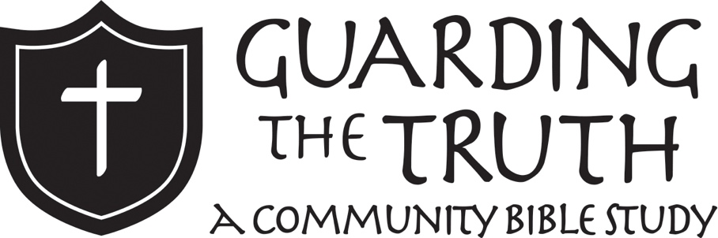
Christian Apologetics: Defending Your Faith
FOR KIDS

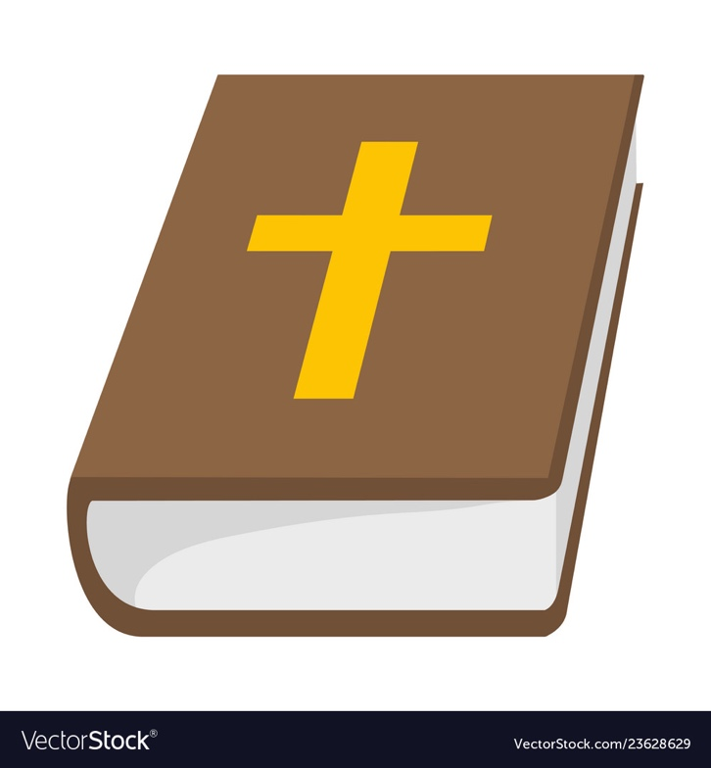

Lesson 1

Goals
- Understand what apologetics is
- Learn why we need to be able to defend our faith
- See avenues of how we can defend Christianity

What is Apologetics?
Apologetics. That’s a big word! To begin our journey, we must learn what this word means. In ancient Greece, when someone was accused of doing something wrong in court they were allowed to defend themselves against those charges. This response was called an “apologia.” The word apologetics comes from this same word.

Looking at the Bible, apologetics means “to provide and answer in return,” or “to defend one’s position.” It is the biblical response of a Christian to attacks on his or her faith. Each follower of Jesus is to be able to make a defense to anyone who wants to ask about Christianity, Jesus, and the Bible.

The Bible says a lot about defending our faith. Read 1 Peter 3:15-16. What does it say we are to be able to do? How are we to do it? Record your answers below.
_____________________________________________________________________________________
_____________________________________________________________________________________
_____________________________________________________________________________________
_____________________________________________________________________________________
_____________________________________________________________________________________

Why Do We Need Apologetics?
Why do we need apologetics? Why do we need to be able to defend our faith? Let’s look and see what Scripture has to say about the matter.

First, look at 2 Timothy 4:3-4. What does the apostle Paul say about what people will do? Do you think we are living in a time where this is the case?
_____________________________________________________________________________________
_____________________________________________________________________________________
_____________________________________________________________________________________
_____________________________________________________________________________________
_____________________________________________________________________________________

Now look at 2 Peter 2:1-3. What does Peter say that false prophets will do?
_____________________________________________________________________________________
_____________________________________________________________________________________
_____________________________________________________________________________________
_____________________________________________________________________________________
_____________________________________________________________________________________

Most of the people in the world do not believe in Jesus. In fact, many of them believe in other religions, and some of them even attack Christianity. They say that Christianity cannot be true and that there is no evidence for it. Because many attack Christianity, we who follow Jesus need to be able to defend it. In addition, many who claim to be Christians teach false things because they are deceived or because they gain from it. We need to be able to recognize these people as well.

How Do We Do Apologetics?
Apologetics seeks to show that the Christian faith is true. How can we do this? There are three major topics we can talk about to defend our faith: Experience, Facts, and Miracles.

Experience is what happens to a believer as a result of faith in Jesus. It is your personal experience with God and how God changes your life. It is very hard for someone to deny what has happened in your life.

Facts are things in the world that can be proven and that help prove that the Bible and Christianity are true. These facts can come in all sorts of ways including history, archaeology, and Bible manuscripts.

Miracles are things that God has done that are beyond the capability of regular people. Many miracles have been recorded in the Bible, including God’s works in the Old Testament and Jesus’ healings in the New Testament. God can still do miracles today too!

Each of these topics alone would be a decent defense, but all of them together makes for a GREAT defense of the faith.

Faith and Reason
Many people have talked about faith and reason in Christianity. Faith is putting your belief in something, even when you cannot see it. Reason is having a logical explanation for something. So, is Christianity about faith or reason? Do you have to believe in God blindly with no evidence? Or do you have to have a perfect rational argument to believe in God?

Good apologetics recognizes that we need both faith and reason. On the one hand, God created people with minds and expects people to use them to think through things well. On the other hand, Hebrews 11:6 tells us that it is impossible to please God without faith. Christians are to live with faith in Jesus and with a trust that God’s Word is true while also confirming that through our reasoning.

Importance of the Bible
The Bible is our main guide for life as Christians. It directs the way we live our lives. In the same way, the Bible directs how we defend our faith too. We can always go back to the Bible when we hear people say things that we think are not true to compare it to what God says. In addition, we need to know what the Bible says so that we can defend it well, and we need to defend it in a way that honors God.

Read Ps. 119:105. How should we see the Bible in our lives and in our quest to defend our faith?
_____________________________________________________________________________________
_____________________________________________________________________________________
_____________________________________________________________________________________
_____________________________________________________________________________________
Review
Answer these questions to review what you’ve learned today!

What is apologetics?

Why do we need to be able to defend our faith?

What are the three major topics we can talk about when we defend our faith?

Is apologetics about faith, reason, or both?

What book is the guide for Christians to defend their faith?

Lesson 2

Goals
- Understand different beliefs about God
- See arguments for God’s existence
- Contemplate Jesus’ claim to be God

Beliefs about God
The world has many different beliefs about God’s existence. Here are three common beliefs:

No gods exist
In this view, any concept of a supernatural god is rejected. They believe that there is a scientific explanation for how the universe came into being. In our age this is called atheism.

Many gods exist
This belief is that the world is full of many different kinds of gods. They all exist and they all have different responsibilities. Ancient Egyptian religions followed this view, which we call polytheism.

One god exists
This worldview is that one god exists in the world. The universe came into being through the action of this one god. Only the one god is worshipped. An example of this monotheism is Christianity. We believe there is one true God.

Does God Exist?
Many people have tried to prove God’s existence. If someone asked you to prove that God exists, what would you say to them? Write your explanation below.
_____________________________________________________________________________________
_____________________________________________________________________________________
_____________________________________________________________________________________
_____________________________________________________________________________________
_____________________________________________________________________________________
_____________________________________________________________________________________
_____________________________________________________________________________________
_____________________________________________________________________________________

It’s hard to explain that isn’t it?! Don’t worry, some of the smartest people in the world don’t even know how to explain God’s existence. Below are some arguments made by some really smart followers of Jesus to help us defend the existence of God.
Watchmaker
A man named William Paley used an argument with the analogy of a watch. He said that if there is a watch, there must be a watchmaker. So, since the universe exists, there must be a maker of the universe.

Beginning of the Universe
The universe had to begin at some point. There are two big options for how we understand this. First, it could happen completely by chance and it all came together perfectly. Second, God’s hand could be involved. Christians believe that God is Creator.

Patterns in the World
There are regular patterns in the world we live in. Every day, the sun rises and the sun sets. There are 365 days in a year. Christians believe that this did not happen by chance, but that God was involved in making things this way.

Good and Evil
People have a sense of right and wrong. When someone is murdered, everyone knows it is bad. If you believe in God, then God sets the standard for right and wrong. If you believe in no God then there is no standard for good and evil. With no God to guide you, you can do anything and everything that you want to do.

Human Religions
Christians seem to be inherently religious. For all of time people have acknowledged a spiritual aspect to the world.

Is Jesus God?
Christianity is specifically centered on Jesus. Read the following verses about Jesus and record what they say about Him being God.

John 5:18
_____________________________________________________________________________________
_____________________________________________________________________________________

John 10:30
_____________________________________________________________________________________
_____________________________________________________________________________________

Mark 9:37
_____________________________________________________________________________________
_____________________________________________________________________________________

Mark 14:61-64
_____________________________________________________________________________________
_____________________________________________________________________________________
Jesus claimed to be God. There are four responses to Jesus claiming to be God.
1. Jesus lied. He knew he was not God but deceived people on purpose.
2. Jesus was crazy. He believed he was God but he did not know what he was talking about.
3. The Bible is a legend. The stories we have about Jesus are completely made up.
4. Jesus told the truth. His life and actions speak to his character as God. Then, the explosion of the church after his ascension shows that his followers truly experienced him and believed him. The church that began spreading 2,000 years ago is still around today, which is a testament that Jesus did not lie.
Ultimately, everyone believes something. They put their faith in something. Our faith as Christians is a belief in Jesus based on the information we have about the existence of God and the life of Jesus. There are many more things that inform our faith as well, which we will be getting into in the coming lessons!

Review
Answer these questions to review what you’ve learned today!

What are the three common beliefs about God’s existence?

Imagine your best friend, who is not a Christian, comes up to you and says, “Do you believe there is a God out there? If so, why?” How would you respond? Use an argument from the lesson about God’s existence to help you.

What are the four options for responding to Jesus’ claim to be God?

How do you respond to Jesus’ claim to be God?

Lesson 3

Goals
- Learn about the trustworthiness of the Bible
- Look up what the Bible says about itself
- See prophecies and their fulfillments

Reliability of the Bible
Many people in history have questioned if the Bible is trustworthy or not. Believing the Bible is ultimately a matter of informed faith. You have a choice to either believe what the Bible says or not. You believe in Jesus or you do not. However, there are areas of evidence that point towards the Bible’s reliability. Let’s explore two of them!

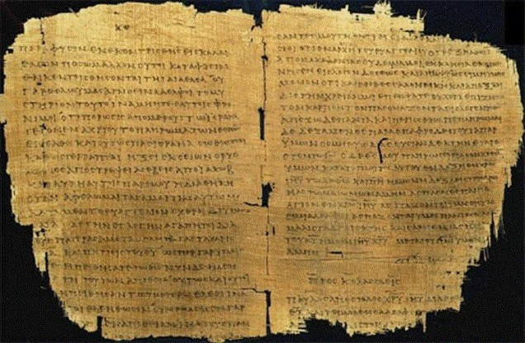
Manuscript Evidence
The Bible was written thousands of years ago on ancient manuscripts. The Old Testament was written in Hebrew and the New Testament was written in Greek. Besides the Bible, the ancient manuscript with the most copies is Homer’s Iliad with 643 copies. However, there are 5,300 known Greek manuscripts of the New Testament! The fact that we have so many copies of the Bible point to its reliability.

Manuscript Accuracy
Manuscripts had to be copied so they could be passed down from generation to generation. Scribes copied manuscripts, and they were incredibly accurate. If even one error was found, the entire copy was destroyed. Even manuscripts that are thousands of years apart are similar with only very few differences.

The Bible on the Bible
The Bible talks about its own reliability too. Look of the following verses and write what they say about the Bible!

2 Timothy 3:16
_____________________________________________________________________________________
_____________________________________________________________________________________

2 Peter 1:21
_____________________________________________________________________________________
_____________________________________________________________________________________

Prophecy
Another amazing thing about the Bible is that there are no contradictions. Although over 40 authors wrote over 2,000 years in 66 books, everything is consistent! Prophecies were made and fulfilled, and some of them have yet to be fulfilled. This is one of the greatest evidences within the Bible for its trustworthiness. On the next page, look up these prophecies about Jesus and write down what they say. Then look up the different fulfillments and write what they say. Then draw a line to match the prophecies with the passage that shows its fulfillment! Answers are on the last page of the lesson.

Prophecies Fulfillments
Isaiah 7:14 Acts 1:9

Isaiah 9:1 Luke 1:26-28

Psalm 78:2 Acts 2:31

Isaiah 53:12 Matthew 4:12-15

Psalm 16:10 Matthew 27:38

Psalm 68:18 Matthew 13:34

Review
Answer these questions to review what you’ve learned today!

What ancient manuscript has the most copies of any in the world?

Why does prophecy help prove the Bible’s reliability?

Answers for the Prophecy-Fulfillment look-up exercise
Prophecy about Jesus | OT Reference | NT Fulfillment
Born of a virgin | Isaiah 7:14 | Luke 1:26-28
His ministry in Galilee | Isaiah 9:1 | Matthew 4:12-15
Teacher of parables | Psalm 78:2 | Matthew 13:34
Crucified with thieves | Isaiah 53:12 | Matthew 27:38
His resurrection | Psalm 16:10 | Acts 2:31
His ascension | Psalm 68:18 | Acts 1:9
Lesson 4

Goals
- Learn what archaeology is
- Understand how archaeology confirms the Bible’s historical accuracy
- See archaeological evidence for the Bible’s reliability

What is Archaeology?
Archaeology studies history through ancient artifacts. It provides a record of the culture and lifestyles of people within a time in history Through different objects we can understand peoples’ lives, and specifically about their religion.

Archaeology provides great evidence for the Bible as well. It cannot prove that what the Bible says is true; however, it confirms that the Bible is historically accurate. It shows that the things we read in the Bible are true to the time period, and many places we read about in Scripture we have a lot of knowledge about!

Archaeology Examples
There are countless examples of how archaeology confirms the Bible’s reliability. Let’s look at some!

Bethesda
In John 5:1-2, the fourth Gospel writer speaks of “a pool in Jerusalem, by the Sheep Gate, called in Hebrew ‘Bethesda’, which has five porticoes”. Until the 20th century, there was no evidence outside of John’s Gospel for such a place and critics questioned John’s reliability. Then in the 1930s, the pool was uncovered by archaeologists — complete with four colonnades around the edges and one across the middle. Here it is below!

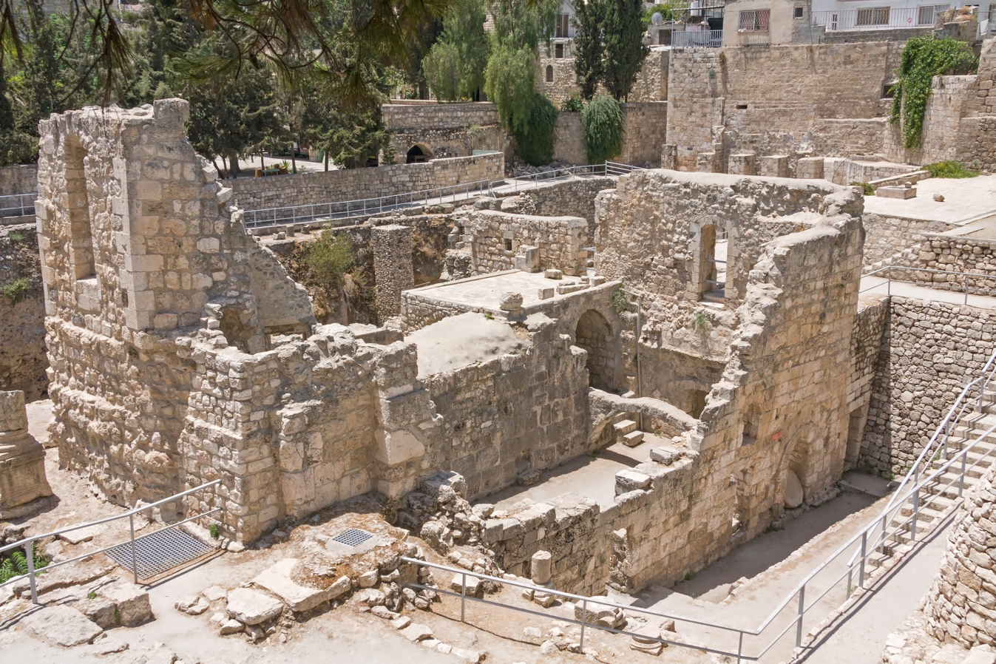

Jericho
Archaeologists have dug into the ground to find the old remains of Jericho. This is called an “excavation.” These people have found that “something” happened to the city walls at a specific date in a specific way.

What does the Bible say happened to Jericho? Read Joshua 6 and record what the Bible says. This matches up with the archaeological evidence for Jericho- how cool it that?!
_____________________________________________________________________________________
_____________________________________________________________________________________
_____________________________________________________________________________________
_____________________________________________________________________________________
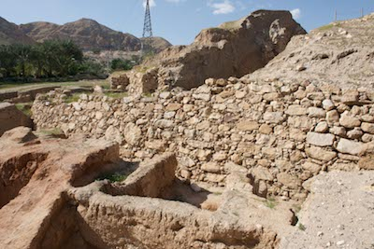
Excavation of Jericho
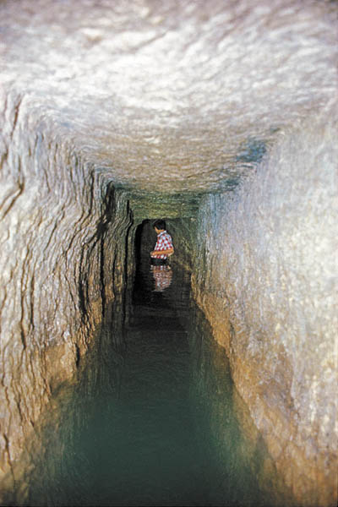

Jerusalem Water Tunnel
Many scholars used to claim that Jerusalem didn’t even exist in the time of King David. However, in the 1990s a Canaanite water tunnel from before the time of David was found! This proved that Jerusalem not only existed but had a water tunnel. Why is this important? Read 2 Samuel 5:6-10 and record what the Bible says David used to attack his enemies.
_____________________________________________________________________________________
_____________________________________________________________________________________
_____________________________________________________________________________________
_____________________________________________________________________________________
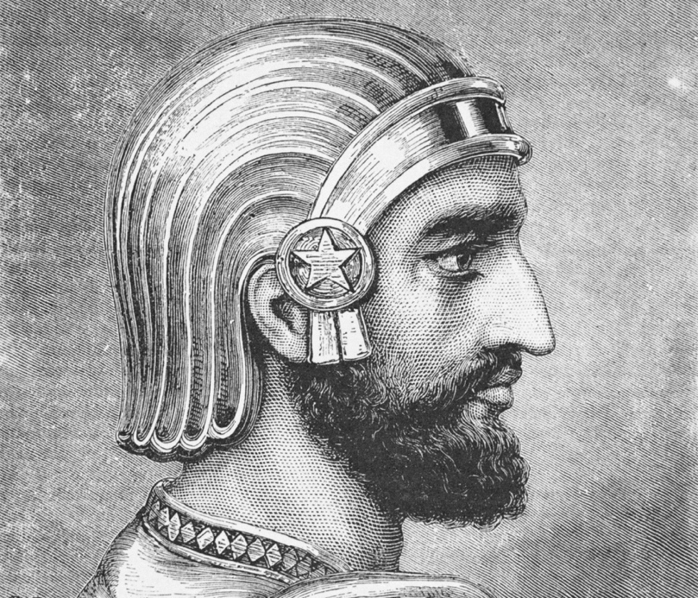
King Cyrus
King Cyrus of Persia, or Cyrus the Great, is a well-known historical figure with many artifacts that prove his existence. King Cyrus also shows up in the Bible! Read 2 Chronicles 36:23 and Ezra 1:2-4. What does the Bible record Cyrus saying?

_____________________________________________________________________________________
_____________________________________________________________________________________
_____________________________________________________________________________________
_____________________________________________________________________________________

There are a few books in the Bible that show that Israelites were allowed to return to their land and rebuild their temples. Not only is this written in the Bible, but a cylinder with writing was discovered that confirms that Cyrus actually did this. Again, the Bible’s record is confirmed by archaeological findings.

Conclusion
At the end of the day, the Bible is something you have to believe in. Archaeology is a useful tool, but it cannot prove the Bible is true. However, we have great evidence outside the Bible to believe that the Bible is truly accurate!
Review
Answer these questions to review what you’ve learned today!

What is archaeology?

Can archaeology prove the Bible is true? What does it do?

What is it called when you dig through old city remains looking for artifacts?

Give an example of archaeological evidence that matches up with the Bible.
Lesson 5

Goals
- Learn about the inspiration of Scripture
- Understand the authority of the Bible

The Inspiration of Scripture
What does it mean that God “inspired” Scripture? To see, let’s look up 2 Timothy 3:16. Look it up in the following translations of this verse to see what might be meant by “inspiration.” To find the different translations, go on a website like Biblegateway.com.

American Standard Version

English Standard Version

New International Version

New American Standard Bible

The NIV provides perhaps the best translation here. All Scripture is God-breathed. The human authors still got to write with their own personalities, but they did so under the inspiration of the Spirit. God breathed his word through these people. The Holy Spirit guided them in their writings in a way approved by God. Therefore, inspiration is the guidance and direction of the Holy Spirit upon the authors of the Bible to write in accordance with God’s will.

The Authority of Scripture
The human authors of Scripture claimed to have authority from God. Look up the following verses and record who the writer was and what they claimed about their message being from God.

Isaiah 1:10

Jeremiah 1:4

Ezekiel 3:16

Malachi 1:1-2

Joel 1:1

Jesus saw the Old Testament as authoritative too. A prime example of this is Matthew 4:1-11. Here, Satan tempts Jesus three times, and each time Jesus responds with Old Testament Scripture. Read this story in Matthew, then look up the following Old Testament verses that Jesus quotes to see that he views the Old Testament as authoritative for His life.

Deuteronomy 8:3

Deuteronomy 6:16

Deuteronomy 6:13

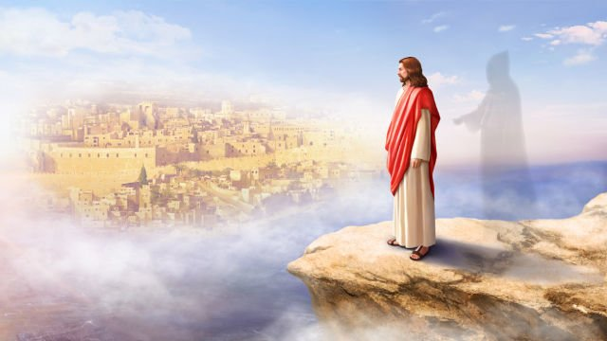
Conclusion
To defend our faith, it’s important to first know that God’s Word was inspired by Him. Second, the Bible has authority from God. That authority speaks into our lives today and can also be used to fend off attacks like Jesus did.

Review
Answer these questions to review what you’ve learned today!

What does it mean to say that the Bible is inspired by God?

What authority did the Old Testament prophets claim when writing Scripture?

Did Jesus see the Old Testament as authoritative? How do you know?

Lesson 6

Goals
- Understand the importance of experiencing God in defending faith
- Learn how to tell your testimony

Experiencing God
Each person is different, and each person has a different experience of God. People have different backgrounds, cultures, and families. The beautiful thing is that the Holy Spirit speaks into each and every one of those situations. Anyone can put their faith in Jesus for the forgiveness of their sins.

Read 1 Corinthians 2:10-12. What does this passage say God has done through the Holy Spirit (verse 10)?

_____________________________________________________________________________________
_____________________________________________________________________________________
_____________________________________________________________________________________
_____________________________________________________________________________________

Why has He done this (verse 12)?
_____________________________________________________________________________________
_____________________________________________________________________________________
_____________________________________________________________________________________
_____________________________________________________________________________________

God has chosen to reveal himself to us through the Holy Spirit. God has revealed himself through the bible in ways that we can understand. We can think about them. We can interact with them! This is our experience as believers. God’s Word is not just true but it is useful to our lives. We can put them to work as part of our experience in following God.

Read the following verses and record what they say about experiencing God.

Psalm 16:11

Psalm 34:8

Psalm 42:1-2

Telling your Testimony
We each might have a different experience of God, but it is important for each of us to be able to share it with others! When we share our experience of God it is called a “testimony.” The Apostle Paul shared his testimony many times, and one example is in Acts 22:1-21. Read these verses, and on the next page record a summary of what his testimony was.

_____________________________________________________________________________________
_____________________________________________________________________________________
_____________________________________________________________________________________
_____________________________________________________________________________________
_____________________________________________________________________________________
_____________________________________________________________________________________
_____________________________________________________________________________________

Just like Paul, it is important for every Christian to be able to summarize his or her testimony in a few short sentences that will take only a few minutes to share. Then, you are prepared to share what God has done in your life to another person who doesn’t know Jesus. Take some time and write out six key sentences to your testimony. These might be major ways God has moved in your life or things you would want to share with someone else.

1.

2.

3.

4.

5.

6.

Review
Answer these questions to review what you’ve learned today!

Do people experience God differently?

What is one way you have experienced God recently?

Imagine someone asked you to share about an experience you had with God. What would you say to them?

Practice telling your testimony to a parent or friend. Have them play the role of a non-Christian and share what God has done in your life!

Lesson 7

Goals
- See the different between general and special revelation
- Learn how the Bible and Science interact

General and Special Revelation
God has revealed himself to us in different ways. Overall, we can categorize them into special revelation and general revelation.

Special revelation is specific truths that God has revealed to us through His Word. Read John 1:14. What does this verse specifically reveal about God?
_____________________________________________________________________________________
_____________________________________________________________________________________
_____________________________________________________________________________________

General revelation is general truths that can be known about God through nature. Read Psalm 19:1-4. What does this passage say about how God can be known through creation?
_____________________________________________________________________________________
_____________________________________________________________________________________
_____________________________________________________________________________________

Christians can experience and know God through both special and general revelation. Therefore, the Bible is important to read God’s Word and science is also important to study God’s creation.

The Bible and Science
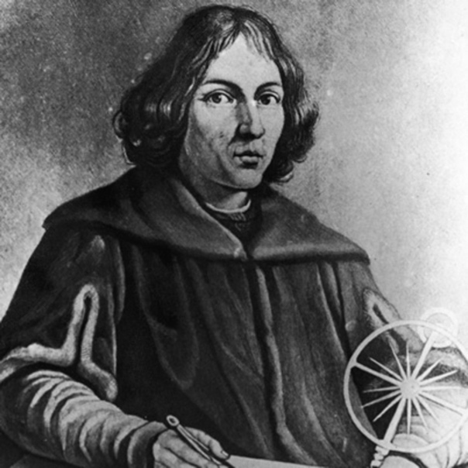
The rise of modern science started with Copernicus. He observed that the earth revolved around the sun, even though up until that point everyone thought that the sun revolved around the earth. Galileo agreed with Copernicus, but the church forced him to renounce his beliefs. Nonetheless, from 1200-1600 the most influential scientists like these two men believed in God and the Bible.

Copernicus

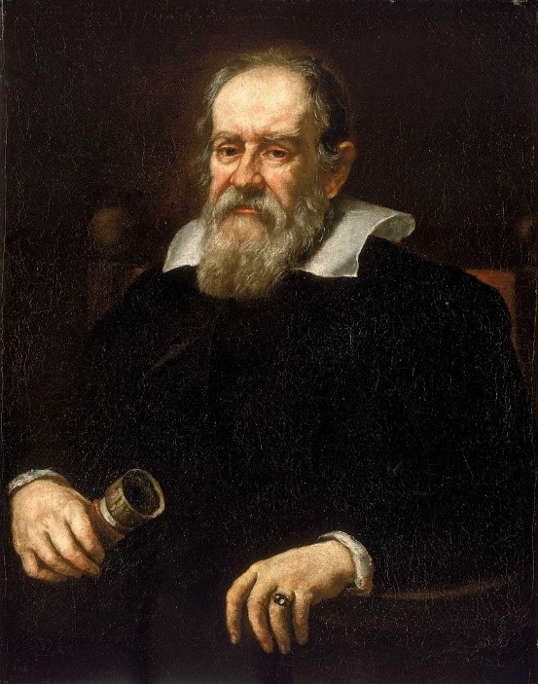
However, after the 1600s many scientists gave up on the idea that God exists. This could have happened because the church drove out a number of good scientists like Galileo. Unfortunately, in the case of Galileo the church was shown to be wrong, and the divide with science had already become large. So, in the 1700s and 1800s God was pushed to the outer edges or science.
Galileo
Though there has been a rift between Christianity and Science in the past, many people today have helped bring them together to show how science actually provides evidence for God and the Bible. Here is one example.

One of the most important discoveries was made by Edwin Hubble when he discovered many other galaxies like our own. He found that other galaxies are retreating from us with a speed that matches their distance away from us. In other words, the universe is expanding. If you work this backwards, it becomes very clear that the universe had one common starting point. There was one creation event at one point in time.

This makes perfect sense for people who trust in God! Read Genesis 1:1. What does the Bible say about a point of the universe coming into existence?
_____________________________________________________________________________________
_____________________________________________________________________________________
_____________________________________________________________________________________
Therefore, Christians must live in the tension when it comes to science. What does living in the tension mean? Let’s unpack it:
On the one hand, Christians need to be open to new scientific discoveries and realize the value of these contributions in furthering society and giving evidence for God.
On the other hand, we must realize that many scientists have a bias against God. So, believers must examine carefully what scientists claim and test them against the Bible as the final authority. We can rejoice ultimately as scientific discoveries point toward what we have believed to be true all along.

Review
Answer these questions to review what you’ve learned today!

What is the difference between special and general revelation?

How does the expansion of the universe point to God’s existence?

How should Christians interact with science?

Lesson 8

Goals
- Read the Bible’s claim that Jesus is the only way to God
- See the difference between Christianity and other religions

Jesus is the Only Way
Many people believe that there are many ways to God. However, Christians believe that Jesus is the only way to God. Let’s look at the Biblical grounding for this claim. Look up the following verses and write down what they say.

John 14:6

Acts 4:12

John 3:16

Romans 10:9

John 3:36

1 Timothy 2:5

Christianity and Other Religions
Now let’s look at some other religions to see what they believe.

Eastern Mysticism: Everything is god. You are god. I am god. The tree is god.

Buddhism: the goal is nirvana, or the destruction of desire. In this state of total nothingness, all pain and suffering end. Nirvana must be reached by each person who works out the details for himself or herself.

Hinduism: the goal is also nirvana, but to them it means the reunion with the all-pervading force of the universe. They do not distinguish between God and God’s creation. If good, one is moved up the scale in their rebirth, but if bad one moves down into suffering.

Islam: heaven is achieved by living a life in which one witholds from the things they will get in heaven. One must do the works of the pillas of Islam, like prayer, fasting, visiting Mecca, and more.

In none of these religions can there be assurance of your eternal destiny. Salvation depends on the individual’s works. You must do enough things.

Christianity is different from other religions. Here are a few key beliefs of Christians:
*Salvation is a free gift provided by the finished work of Christ to those who believe
*Good works come as the outflow of the believer’s love for God
*The focus is on what God has done for us

God tells us that we will never earn heaven because we can’t live up to God’s standards. So He took the initiative. Because of His love, he came to earth as a man to rescue us from the death that our sin deserves.

If you were in a conversation where someone was asking how Christianity is different from other religions, what would you say? Spend some time journalling your thoughts below. They don’t have to be perfect!
_____________________________________________________________________________________
_____________________________________________________________________________________
_____________________________________________________________________________________
_____________________________________________________________________________________
_____________________________________________________________________________________
_____________________________________________________________________________________
_____________________________________________________________________________________
_____________________________________________________________________________________
_____________________________________________________________________________________

Here are a few principles you can draw on when someone asks you what the difference between Christianity and other religions is:

1. Christianity is about what God has done for us, not what we can do for God.

2. Salvation is a free gift, not something you can earn.

3. Christianity is about relationship with God, not just religious rules.

4. Christianity has a foundation on a historical event: the resurrection of Jesus Christ.

5. In Christianity you can have assurance of where you will be for eternity.

Review
Answer these questions to review what you’ve learned today!

What do Christians believe is the only way to God?

What is one Bible verse you could use to talk about Christianity’s belief that Jesus is the only way to the Father?

What are other religions like Hinduism and Islam based upon?

What are five ways Christianity is different from other religions?
Lesson 9

Goals
- Be able to recognize false teaching
- Become aware of modern cults
- Learn how to defend your faith against false teachers

Opposition to the Gospel
Wherever the gospel is proclaimed, there will be challenges from the enemy. Look up 1 Peter 5:8. What does this verse says about the devil’s opposition?
_____________________________________________________________________________________
_____________________________________________________________________________________
_____________________________________________________________________________________
Now read Matthew 7:15-23. According to Jesus, how will we know false prophets? What will happen to them in the end?
_____________________________________________________________________________________
_____________________________________________________________________________________
_____________________________________________________________________________________
_____________________________________________________________________________________
_____________________________________________________________________________________
_____________________________________________________________________________________

Let’s look at a few ways the gospel can be challenged.

False teachers: a false prophet or a false teacher does not appropriately exalt Jesus or teach the truth about Him

Now some false teachers are teaching incorrectly out of misunderstanding the truth. For them, you should point them to the appropriate Scripture for correction. However, there are others who teach falsely because of spiritual blindness. Their spiritual position is in question.

Cults: a cult is a group of people gathered around a specific person or person’s misinterpretation of the Bible.

Cults contain major differences from historic Christianity. However, they insist to be called Christians. It is their wanting to be called Christians that makes them dangerous to the faith.

Walter Martin recognizes common characteristics of cults. Here are a few of them:

- Closed-mindedness
- Attacking others
- Isolation
- Biblical knowledge used inappropriately
False Prophecy: False prophecy is defined for us in Scripture! Read Deuteronomy 18:21-22 and record what it says about false prophecy.
_____________________________________________________________________________________
_____________________________________________________________________________________
_____________________________________________________________________________________
_____________________________________________________________________________________
Modern False Teachings
Today many groups of people are teaching things against the Bible. While we still need to love and pray for these people, it is extremely important that we are able to recognize who they are and what they believe.

Jehovah’s Witnesses: among many things, these people do not believe in the Trinity. They believe after the apostles died the church departed from God’s truth and they have recovered it.

Mormons: Mormons hold the Book of Mormon to be equal to the Bible in terms of Scripture.

Christian Science Church: these people believe that the world is only spiritual and the material world an illusion. Many believe that medicine should not be used and healing should only come through prayer.

How to Defend Your Faith Against False Teaching
Today many groups of people are teaching things against the Bible. What do you do if you are talking to someone who is teaching or believing false doctrine? How can you present the truth of Christianity? Here are a few helpful points.

1. Ask the cultist to define his terms
2. Compare cultist definitions with actual biblical interpretation
3. Clearly define Christian terms
4. Lead them to see the importance of correctly defining terms, especially the doctrine of salvation from sin which most cult systems define wrongly.
5. Present a clear testimony of your own experience of putting your faith in Jesus with the terms as you have defined them.

Review
Answer these questions to review what you’ve learned today!

What is the name for someone who does not appropriately exalt Jesus or teach the truth about Him?

What is a group of people gathered around a specific person or person’s misinterpretation of the Bible?

What is a sign of a cult?

What is a modern false teaching?

How can you defend your faith against someone with false teaching?

Lesson 10

Goals
- Review how to defend your faith

Study Overview
Congratulations! You’ve completed “Christian Apologetics: Defending Your Faith FOR KIDS”! The reason we have gone through these lessons is because we wanted to “be prepared to give an answer to everyone who asks you to give the reason for the hope that you have” (1 Peter 3:15). Now, let’s see what you’ve learned! Try to answer all these questions on your own, only going back to previous lessons if you need to.

What is apologetics?
_____________________________________________________________________________________
_____________________________________________________________________________________
_____________________________________________________________________________________

What book is the guide for Christians to defend their faith?
_____________________________________________________________________________________
_____________________________________________________________________________________
_____________________________________________________________________________________

What are the three common beliefs about God’s existence?
_____________________________________________________________________________________
_____________________________________________________________________________________
_____________________________________________________________________________________
Why does prophecy help prove the Bible’s reliability?
_____________________________________________________________________________________
_____________________________________________________________________________________
_____________________________________________________________________________________

Can archaeology prove the Bible is true? What does it do?
_____________________________________________________________________________________
_____________________________________________________________________________________
_____________________________________________________________________________________

What does it mean to say that the Bible is inspired by God?
_____________________________________________________________________________________
_____________________________________________________________________________________
_____________________________________________________________________________________

In six sentences, share your testimony.
_____________________________________________________________________________________
_____________________________________________________________________________________
_____________________________________________________________________________________

What is the difference between special and general revelation?
_____________________________________________________________________________________
_____________________________________________________________________________________
_____________________________________________________________________________________

What do Christians believe is the only way to God?
_____________________________________________________________________________________
_____________________________________________________________________________________
_____________________________________________________________________________________

How is Christianity different from other religions?
_____________________________________________________________________________________
_____________________________________________________________________________________
_____________________________________________________________________________________

What is a false teacher? What is a cult?
_____________________________________________________________________________________
_____________________________________________________________________________________
_____________________________________________________________________________________

To end our study, write a few things you want to remember when you defend your faith.
_____________________________________________________________________________________
_____________________________________________________________________________________
_____________________________________________________________________________________
_____________________________________________________________________________________
_____________________________________________________________________________________
_____________________________________________________________________________________

I hope you’ve learned a lot and feel better prepared to defend your faith, even as a kid or youth! As you go forward, continue always going back to the Bible and asking for the Holy Spirit’s help as you seek to guard the truth of the gospel of Jesus Christ!

